|  |  |
| --- | --- |
| http://sphotos.ak.fbcdn.net/photos-ak-snc1/v2219/119/28/51288393663/n51288393663_1327303_6197.jpg | old_logo_color |

ASSIGNMENT Week 1

Logistics regression with a neural networks

By

Ahmed Usama Khalifa

Submitted to

Dr. Mohamed Moharram

Electronics and Electrical Communications Engineering Department

FACULTY OF ENGINEERING, CAIRO UNIVERSITY

GIZA, EGYPT

April – 2020

Binary Classification

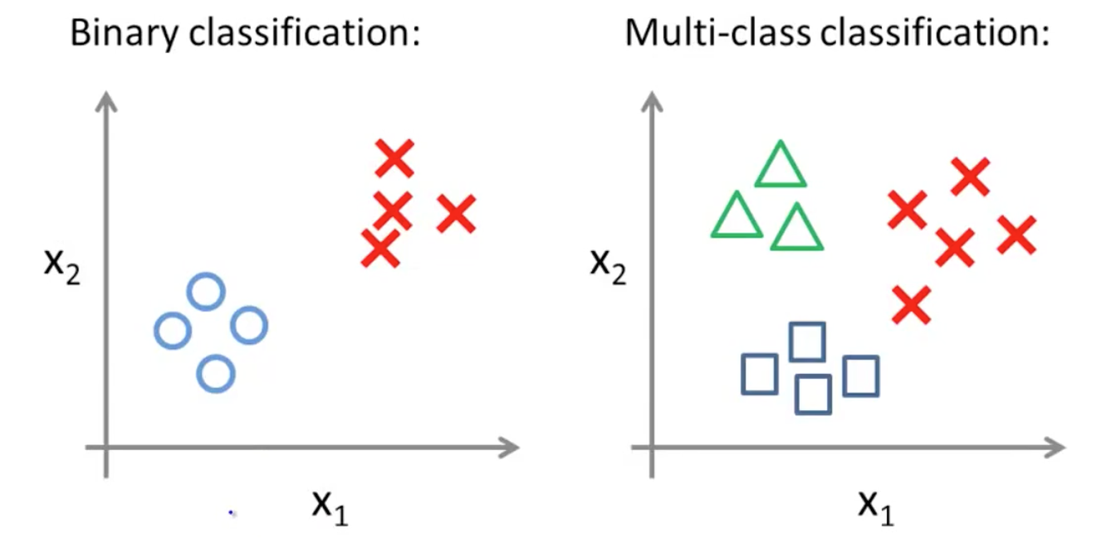

Logistics Regression

